Sishaar Rao

Period 4

Shortest Distance Turn-In

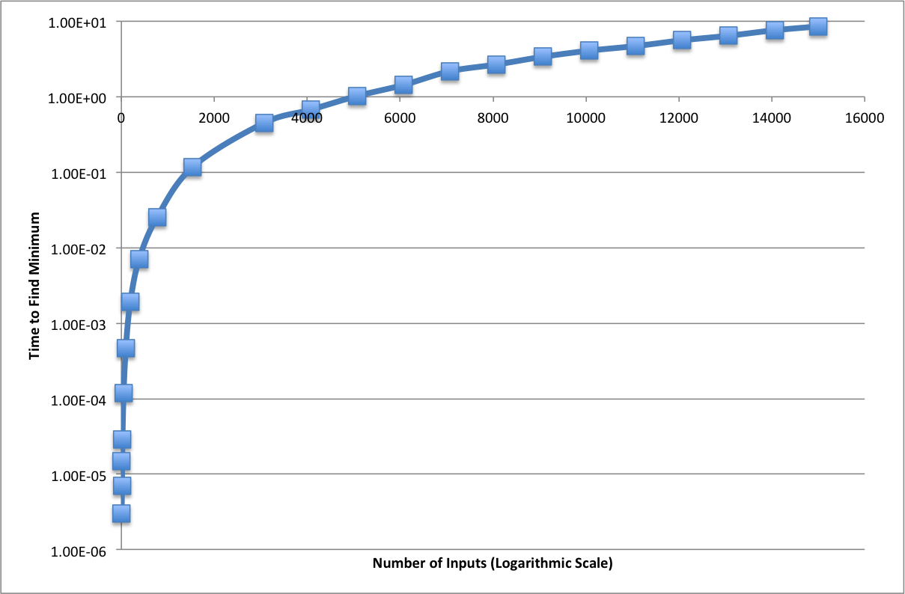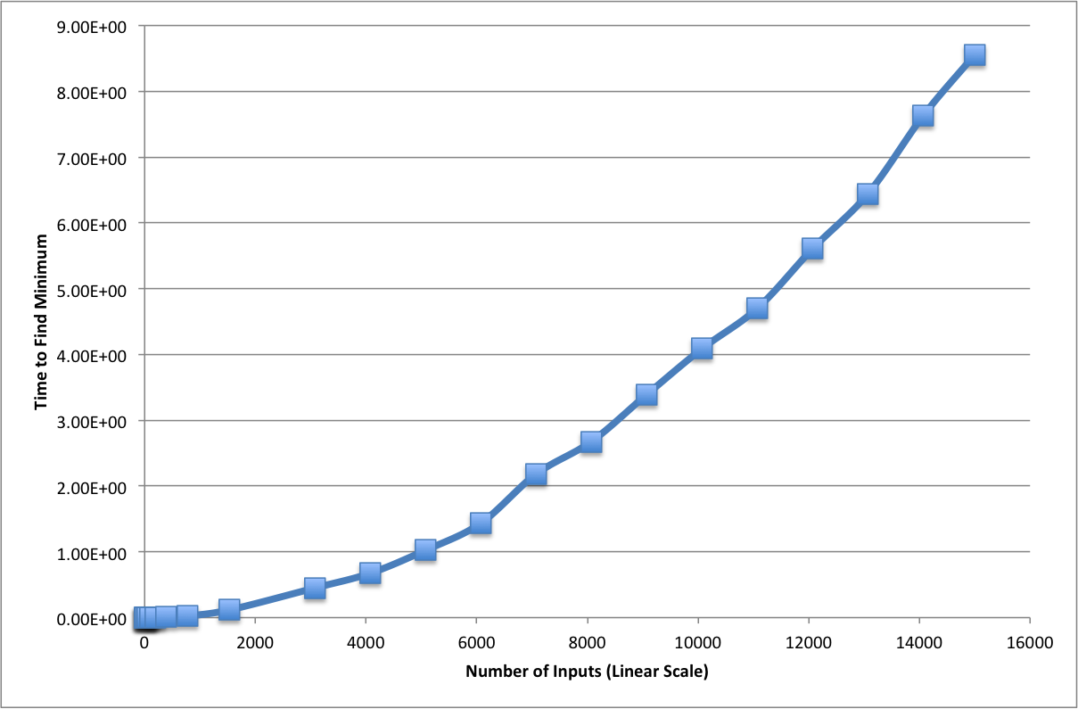Trial 1:

Trial 2: